WATERSHED INDIA- empowering citizens

Strategic Partnership – India Work Programme
Village Information Sheet
1. State: Odisha
2. District: Ganjam 3. Block: Chatrapur
4. Name of gram panchayat:- Podapadar 5. Name of village:-Kumarbegpalli
6. Population of village: -1490 7. Total Household:-336
8. Connectivity: Pucca/Kucha Road :- Pucca
9. Distance from District headquarters:-02km
10. Number of hamlets ( Pada /Sahi) :-08
11 . Name of Pada/Sahi 1:-Tala Sahi 2:-Adua Sahi 3:- Upersahi 4:- Badheisahi 5:- Majhi Sahi 6:-Bauri Sahi 07:-Roada Sahi.08:- Nayakasahi.
11.Social Group:- 1:- Gauda.2:-Khandayat (odia) 3:-Bauri 4:-Das 5:-Brahmini 6:- Dandashi 7:-Badhei 8:- Bhandari 9:- Sunari 10:- Gudia
12.Religion:- Hindu
13. Social Group wise Catagory:-
General Category | S C Category | S T Category | OBC Category
Brahmini | Dandasi | 0 | Gouda
0 | Das | 0 | Badhei
0 | Bauri | 0 | Gudia
0 | Nayak | 0 | Khandayat(odia)
 |  |  | Sunari

14. Sahi/Pada wise House hold(Social Group)
SN | Name of the Hamlet/Sahi | Household (General) | Household (SC) | Household (ST) | Household (OBC) | Total
1 | Talasahi | 0 | 0 | 0 | 50 | 50
2 | Adua Sahi | 0 | 0 | 0 | 40 | 40
3 | Upersahi | 06 | 0 | 0 | 54 | 60
4 | Badheisahi | 09 | 0 | 0 | 15 | 24
5 | Majhi Sahi | 0 | 0 | 0 | 50 | 50
6 | Bauri Sahi | 0 | 36 | 0 | 10 | 46
7 | Roada Sahi | 0 | 05 | 0 | 55 | 60
8 | Nayakasahi | 0 | 06 | 0 | 0 | 06
 | Total | 15 | 47 | 0 | 274 | 336

15.Sahi /pada wise Oqupation
 | Talasahi -50 | Adua Sahi-40 | Upersahi-60 | Badheisahi-24 | Majhi Sahi-50 | Bauri Sahi-46 | Roada Sahi-60 | Nayakasahi-06 | Total
 | 1 | 2 | 3 | 4 | 5 | 6 | 7 | 8 | 09
Fishing | 0 | 0 | 0 | 0 | 0 | 0 | 0 | 0 | 0
Marginal Farmer (<2.5Acer) | 46 | 30 | 50 | 0 | 40 | 04 | 50 | 06 | 226
Medium/large Farmer>2.5 | 04 | 02 | 02 | 0 | 02 | 0 | 0 | 0 | 10
Labourers | 10 | 05 | 10 | 24 | 10 | 30 | 50 | 05 | 144
Service | 05 | 02 | 20 | 01 | 30 | 04 | 02 | 02 | 66
Small Business | 03 | 02 | 03 | 01 | 0 | 01 | 01 | 0 | 11
Keoda collection | 05 | 0 | 0 | 0 | 0 | 0 | 0 | 0 | 05
Kaju collection | 0 | 0 | 0 | 0 | 0 | 0 | 10 | 0 | 10

16. Income Generation Unit in Village:-
1) Kaju Processing Unit:-Yes At Humar
2) Keoda Processing Unit:- No
3; Income generation Activates/Unit:-Ass Bricks In Humara village Border
17. Functional Village Water & sanitation Committee: - No
18. Numbers of user / pani committee in the village:-No
No separate Committee for water users ,Village GKS Functioning .
19. Institution Mapping:-
SN | Institution | Type | Distance to Village | No of Centre | Key Authority/Point person | Role
1 | Anganwadi Center | Cente,Sub Center | In Village | 02 | AWW | Health
2 | School (1To 5) | Praimery | In Village | 01 | Headmaster | Education
3 | Medical | CHC | Chatarpur | 01 | Medical Officer | Health
3 | Health Center | ANM | In Village | Camp | ANM | Healh
4 | NGO | No | No | No
5 | Bank |  | Chatarpur | 10
6 | SHG | Group | In Village | 06 | SHG Leader/ CRP | Savings &Loan
7 | Post office | Village post office | Humar | 01 | Village post Master | Comunication
8 | Panchayat Office |  | Podapadar | 01 | Sarapanch | Village Devlopment
9 | Police Station | Thana | Chatarpur | 01 | Police In Charge | Social sequrity
10 | Farm  ers Cooperative Society | Village coopertive | In Humara | 01 | Secretary | Loan

20. Main Source of Drinking Water:-
SN | Type Recourse | Nos/ units | Coverage (%Villagers) | Function
1 | Pipe water System Household connecting | NA | NA | NA
2 | Hand Pump | 11 | 98% | Functioning 09
3 | Open well | 09 | N0
4 | Personal Burwell | 10 | 02%
5 | Personal open well | 0 | 0

21. Sanitation Coverage:-
SN | Type | %of village population
1 | Toilet Coverage | 15%
2 | Toilet Usage | 10%
22. Resource Map & Social Map
1) Resource Map
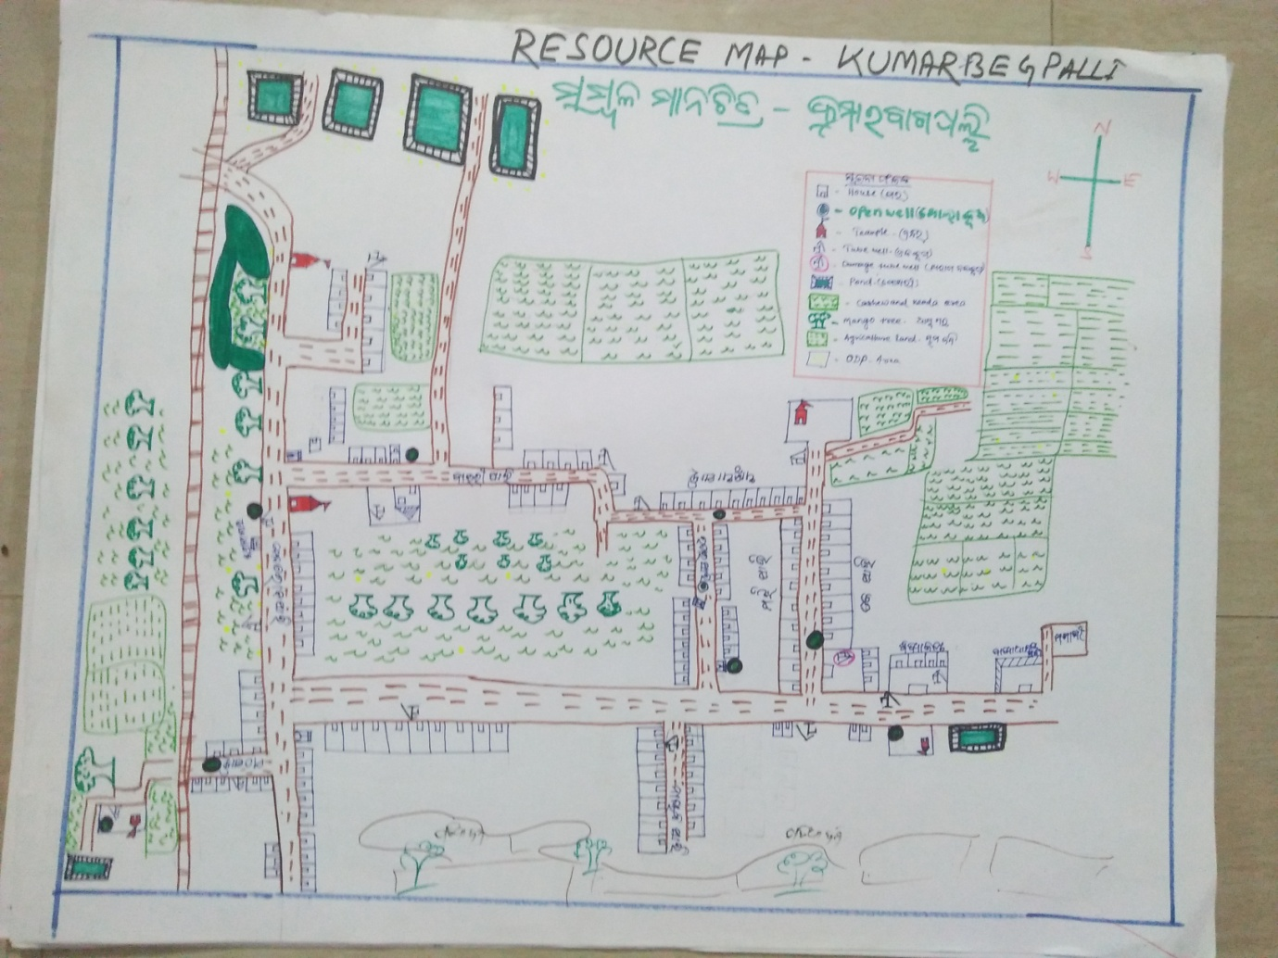

2) Social Map
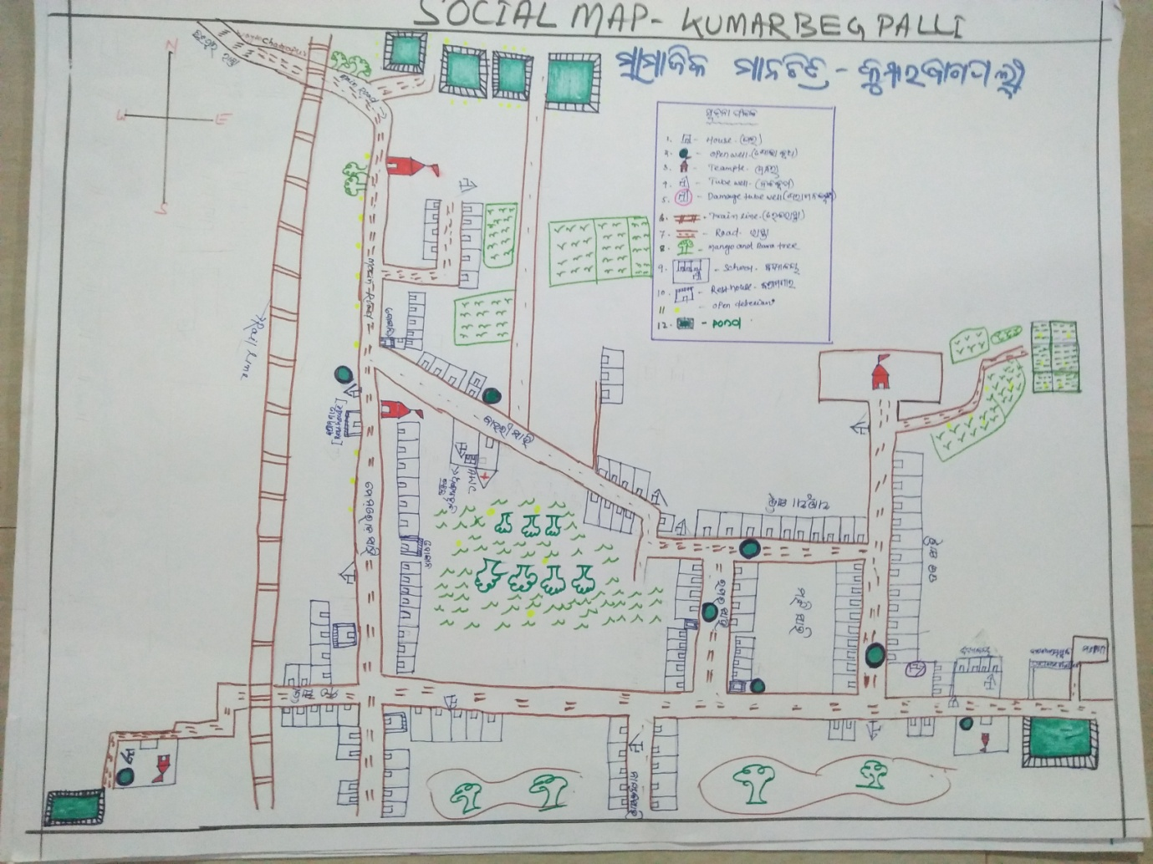
23 . Water Bodies;-
SN | Surface water Bodies | Period for Which water Available | Purpose of Use | For Eache purpose indicate Month (From –to) | Who Manage
1 | River & Stream | NA | NA | NA | NA
2 | Chanel & Canal | NA | NA | NA | NA
3 | Lake | NA | NA | NA | NA
4 | Pond
5 | Open Dug well
(Mark on Resource Map )
24. Seasonal Calendar For Resources Availability:-
 | Jan | Feb. | Mar | Apr | May | June | july | Aug | Sept | Oct | Nov | Dec
Capture Fishing | 0 | 0 | 0 | 0 | 0 | 0 | 0 | 0 | 0 | 0 | 0 | 0
Culture Fishing | 0 | 0 | 0 | 0 | 0 | 0 | 0 | 0 | 0 | 0 | 0 | 0
Aquatic plant collection | 0 | 0 | 0 | 0 | 0 | 0 | 0 | 0 | 0 | 0 | 0 | 0
Agriculture | 0 | 0 | 0 | 0 | 0 | ¥ | ¥ | ¥ | ¥ | ¥ | ¥ | ¥
Kaju collecting | 0 | 0 | ¥ | ¥ | ¥ | 0 | 0 | 0 | 0 | 0 | 0 | 0
Keoda collection
Labour Work | ¥ | ¥ | ¥ | ¥ | ¥ | ¥ | ¥ | ¥ | ¥ | ¥ | ¥ | ¥

25. Hazard & Vulnerability Mapping :-
SN | Type of Hazard | Year of Hazard | Period of Hazard | If flood days when water Water logging | Areas Inundated
1 | Super cyclon | 1999
2 | phailin | 2013
26. Time &Trained Analysis of Resource Vulnerability:-
SN | Year | Type Hazard/Event | Effect/ affect Waterresourse
1 | 1999 | Super Cycone | Pond & Tubewell fill with Salain water
2 | 2013 | Phaini | Pond & Tubewell fill with Salain water
3 | 2014 | Hoodhud

