WATERSHED INDIA- Empowering Citizens

Strategic Partnership – India Work Programme
Village Information Sheet
1. State: Odisha
2. District: Ganjam 3. Block: Chatrapur
4. Name of Gram panchayat: Podapadar 5. Name of village: Humar
6. Population of village: -2500 7. Total Household:-480
8. Connectivity: Pucca/Kucha Road : Pucca
9. Distance from District headquarters:-04km
10. Number of hamlets ( Pada /Sahi) : 08
11 . Name of Pada/Sahi 1:- Badashi 2:-Majhi sahi 3:-Nuaahi 4:-Bauri Sahi 5:-Redika sahi 6:- Sinibas Nager 7;- Baishnb Bihar 8;- Adua Sahi
12.Social Group:- 1:- Bramhni 2:-kumuti 3: Khandayat 4:-Roul 5:-Senapati 6:-Telugu 7:-Teli 8:-Behera
9:-Liari 10:-gudia 11:-Dhoba 12:-Dandasi 13:-Bauri 14:-Bhandari 15:-Bhadei 16:-Hadi
13.Religion .Hindu
14. Social Group wise Catagory:-
General Category | S C Category | S T Category | OBC Category
Bramhini | Bauri | 0 | Teli
0 | Hadi | 0 | Khandayat
0 | Dandasi | 0 | Bandari
0 | Dhoba | 0 | Gudia
0 | Behera | 0 | Roul
0 | 0 | 0 | Liari
0 | 0 | 0 | Senapati
0 | 0 | 0 | Telugu
0 | 0 | 0 | Badhei
0 | 0 | 0 | Kumuti

15. Sahi/Pada wise House hold(Social Group)
SN | Name of the Hamlet/Sahi | Household (general) | Household (SC) | Household (ST) | Household (OBC) | Total
1 | Badasahi | 01 | 07 | 0 | 107 | 125
2 | Majhi Sahi | 0 | O4 | 0 | 150 | 154
3 | Nuasahi | 0 | 0 | 0 | 54 | 54
4 | Bauri sahi | 0 | 60 | 0 | 0 | 60
5 | Redika Sahi | 0 | 01 | 0 | 19 | 20
6 | Sribash Nager | 0 | 0 | 0 | 0 | 32
7 | Baisnaba Bihara | 01 | 0 | 0 | 24 | 25
8 | Adua Sahi | 0 | 0 | 0 | 20 | 20

16.Sahi /pada wise Oqupation
 | Badasahi | Majhi Sahi | Nuasahi | Bauri sahi | Redika Sahi | Sribash Nager | Baisnaba Bihara | Adua sahi
 | 1 | 2 | 3 | 4 | 5 | 6 | 7 | 8 | 9
Fishing | 20 | 16 | 0 | 0 | 0 | 0 | 0 | 0 | 36
Marginal Farmer (<2.5Acer) | 50 | 79 | 12 | 10 | 06 | 10 | 05 | 05 | 177
Medium/large Farmer>2.5 | 08 | 16 | 12 | 0 | 10 | 05 | 0 | 1 | 52
Labourers | 60 | 60 | 26 | 55 | 20 | 20 | 20 | 16 | 287
Service | 05 | 20 | 15 | 03 | 03 | 0 | 0 | 0 | 48
Small Business | 25 | 30 | 03 | 0 | 07 | 0 | 1 | 0 | 66
Keoda collection | 17 | 20 | 01 | 0 | 0 | 0 | 0 | 0 | 38
Keoda Processing | 0 | 0 | 0 | 0 | 0 | 0 | 0 | 0 | 0
Land less | 6o | 60 | 30 | 55 | O4 | 17 | 20 | 16 | 262

17. Income Generation Unit in Village:-
1) Kaju Processing Unit : Humara
2) Keoda Processing Unit...N0
3; Incomegeneration Activites/Unit. Bailor Farm 2 Nos
18. Functional Village Water & sanitation Committee: - Yes
19. Numbers of user / pani committee in the village:-No
20. GKS Comeet :- Yes
19. Institution Mapping:-
SN | Institution | Type | Distance to Village | No of Centre | Key Authority/Point person | Role
1 | Anganwadi Center |  | In village | 03 | AWW | Helth
2 | School | Praimery | In Village | 01 | Hedmate | Education
3 | Health Center | ANM | Camp | 02 | ANM | Heath
4 | NGO | 0 | 0 | 0 | 0 | 0
5 | Bank | National Bank | Chatrapur | 10 | Branch Manager | Loan
6 | SHG | Saving Group | In village | 10 | SHG Leader | Savings
7 | Post office | Village post office | In Village | 01 | Postmaster | Comunication
8 | Panchayat Office |  | Podapadara
9 | Police Station | Policestation | Chatarpur | O1 | In Charge officer | Protection

20. Main Source of Drinking Water:-
SN | Type Recourse | Nos/ units | Coverage (%Villagers) | Function
1 | Pipe water System Household connecting | 0ne | 100% | Functioning
2 | Hand Pump | 09 | 100% | 03 funtiong
3 | Open well | 05 | 20 | Domestic ues
4 | Personal Burwell | 05 | 2% | Domestic ues
5 | Personal open well | 50 | 60% | Agriculture purpose

21. Sanitation Coverage:-
SN | Type | %of village population
1 | Toilet Coverage | 45%
2 | Toilet Usage | 80%
22. Resource Map & Social Map
1) Resource Map
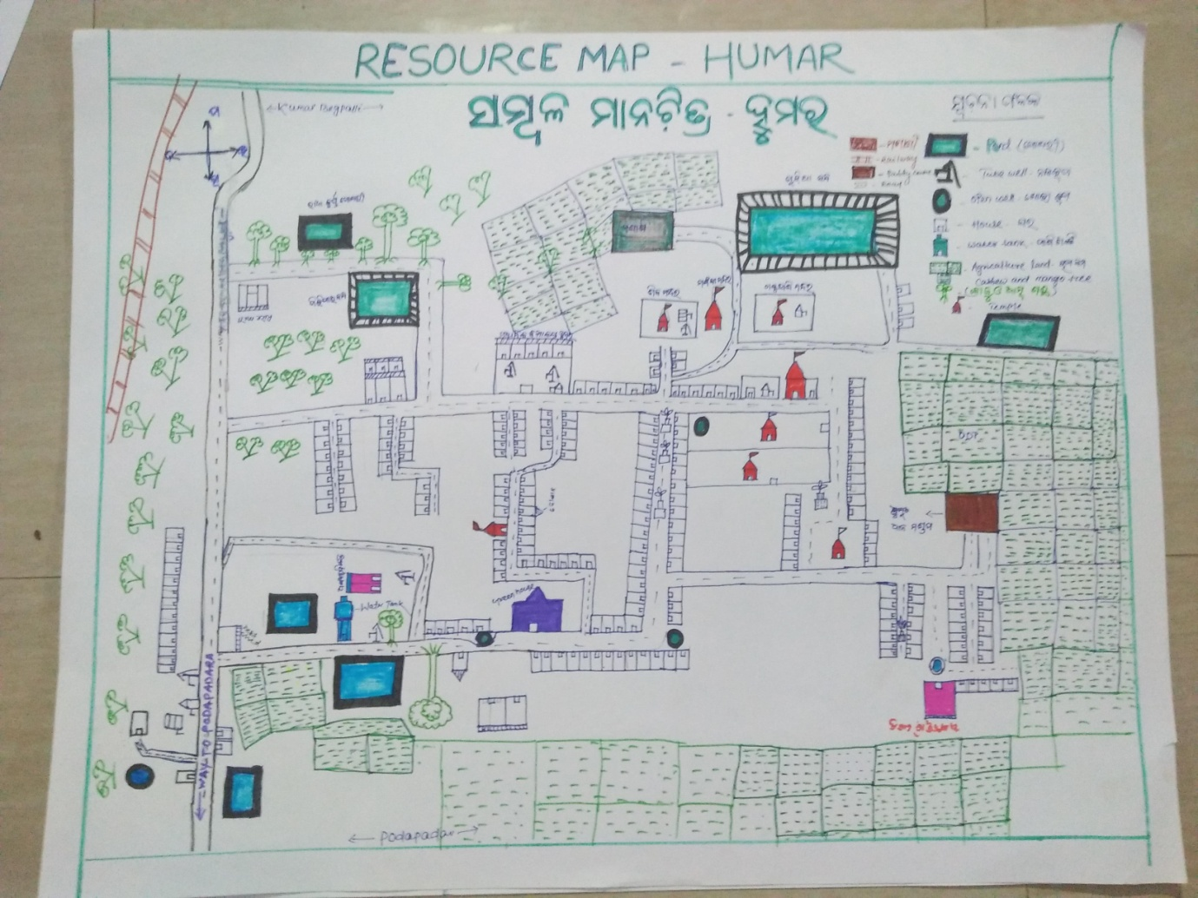

2) Social Map
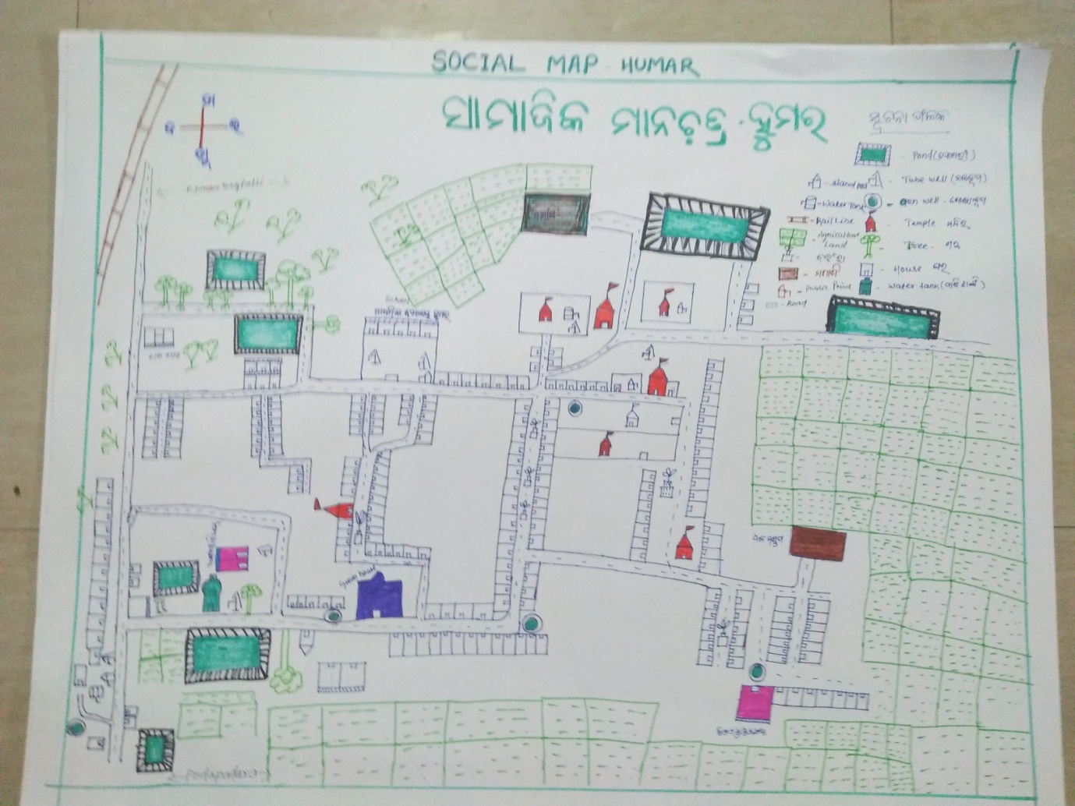
23 . Water Bodies;-
SN | Surface water Bodies | Period for Which water Available | Purpose of Use | For Eache purpose indicate Month (From –to) | Who Manage
1 | River & Stream
2 | Chanel & Canal
3 | Lake
4 | Pond
5 | Open Dug well
(Mark on Resource Map )
24. Seasonal Calendar For Resources Availability:-
 | Jan | Feb. | Mar | Apr | May | June | july | Aug | Sept | Oct | Nov | Dec
Capture Fishing
Culture Fishing
Aquatic plant collection
Agriculture
Kaju collecting
Keoda collection

25. Hazard & Vulnerability Mapping :-
SN | Type of Hazard | Year of Hazard | Period of Hazard | If flood days when water Water logging | Areas Inundated
1 | Super cyclon | 1999
2 | phailin | 2013
26. Time &Trained Analysis of Resource Vulnerability:-
SN | Year | Type Hazard/Event | Effect/ affect Waterresourse
1 | 1999 | Super Cycone | Pond & Tubewell fill with Salain water
2 | 2013 | Phaini | Pond & Tubewell fill with Salain water
3 | 2014 | Hoodhud

