WATERSHED INDIA- empowering citizens

Strategic Partnership – India Work Programme
Village Information Sheet
1. State: Odisha
2. District: Ganjam 3. Block: Chatrapur
4. Name of Gram Panchayat: -Kanamana 5. Name of village: -P.Chhatarpur
6. Population of village:- 2500 7. Total Household:-455
8. Connectivity: Pucca/Kucha Road : Pucca
9. Distance from District headquarters:_02_km
10. Number of hamlets ( Pada /Sahi) : -08
11 . Name of Pada/Sahi 1:- Jayadurga Nagar 2:-Jaganath Bihar 3:-School Sahi 4:-Balaram Sahi 5:-Reddy Sahi 6:-Nayak Sahi 7:-Mainroad Sahi 8:-Behera Sahi
11.Social Group:- 1:- Bramhan 2:-Pattanayak 3:-Gudia 4:-Reddy 5:-Bhandari 6:-Lihari 7:-Patra 8:-Raul 9:-Dhoba 10:-Nayak 11:-Kandara 12:-Dandasi
12.Religion :-Hindu
13. Social Group wise Catagory:-
General Category | S C Category | S T Category | OBC Category
Bramhan | Dhoba |  | Gudia
Pattanayak | Nayak |  | Reddy
 | Kandara |  | Bhandari
 | Dandasi |  | Lihari

14. Sahi/Pada wise House hold(Social Group)
SN | Name of the Hamlet/Sahi | Household (general) | Household (SC) | Household (ST) | Household (OBC) | Total
1 | Jayadurga sahi | 15 | 05 | 0 | 05 | 25
2 | Jagannath Bihar | 30 | 10 | 0 | 05 | 45
3 | School Sahi | 0 | 05 | 0 | 08 | 13
4 | Balaram Sahi | 0 | 20 | 0 | 06 | 26
5 | Radiy Sahi | 0 | 02 | 0 | 100 | 102
6 | Nayak Sahi | 0 | 25 | 0 | 0 | 25
7 | Main Road Sahi | 10 | 20 | 0 | 78 | 108
8 | Behera Sahi | 0 | 100 | 0 | 11 | 111

15.Sahi /pada wise Oqupation
 | Jayadurga sahi | Jagannath Bihar | School Sahi | Balaram Sahi | Radiy Sahi | Nayak Sahi | Main Road Sahi | Behera Sahi
 | 1 | 2 | 3 | 4 | 5 | 6 | 7 |  | 8 | total
Fishing | 0 | 0 | 0 | 0 | 0 | 0 | 0 |  | 0 | 0
Marginal Farmer (<2.5Acer) |  |  | 01 | 06 | 60 | 0 | 30 |  | 60 | 157
Medium/large Farmer>2.5 | 02 | 0 | 0 | 0 | 10 | 0 | 02 |  | 0 | 14
Labourers | 2 | 10 | 2 | 8 | 10 | 22 | 60 |  | 10 | 124
Service | 05 | 25 | 04 | 07 | 03 | 10 | 08 |  | 40 | 102.
Small Business | 15 | 10 | 03 | 05 | 08 | 0 | 05 |  | 08 | 54
Keoda collection | 0 | 0 | 0 | 0 | 01 | 0 | 0 |  | 10 | 11
Kaju collection | 0 | 0 | 04 | 01 | 0 | 15 | 0 |  | 0 | 20

16. Income Generation Unit in Village:-
1) Kaju Processing Unit .02
2) Keoda Processing Unit:01
17. Functional Village Water & sanitation Committee: - No
18. Numbers of user / pani committee in the village:-No
,Village GKS Committee Functioning
19. Institution Mapping:-
SN | Institution | Type | Distance to Village | No of Centre | Key Authority/Point person | Role
1 | Anganwadi Center |  | In village | 03 | AWW | Child & mother care
2 | School | Praimery | In village | 01 | Head mistress | Education
3 | Health Center | PHC | Chatrapur 02 km | 01 | Medical officer | Health
4 | NGO | no | 0 | 0 | 0 | 0
5 | Bank | All Bank | Chatrapur | 10 | Branch Manager | Loan
6 | SHG |  | In village | 20 | SHG Leader | Loan
7 | Post office | Sub Post office | Chatrapur | 01 | Post Master
8 | Panchayat Office |  | Kanamana 02 km | 01 | Sarapancha | Vl  Illage Devlopment
9 | Pollicwstation |  | Chatra pur 02 km | 01 | IIC | Protectionin
20. Main Source of Drinking Water:-
SN | Type Recourse | Nos/ units | Coverage (%Villagers) | Function
1 | Pipe water System Household connecting | 01 | 0% | Not Functiong
2 | Hand Pump | 18 | 80% | Functioning
3 | Open well | 05 | 0%
4 | Personal Burwell | 101 | 20%
5 | Personal open well
21. Sanitation Coverage:-
SN | Type | %of village population
1 | Toilet Coverage | 50%
2 | Toilet Usage | 80%

22. Resource Map & Social Map
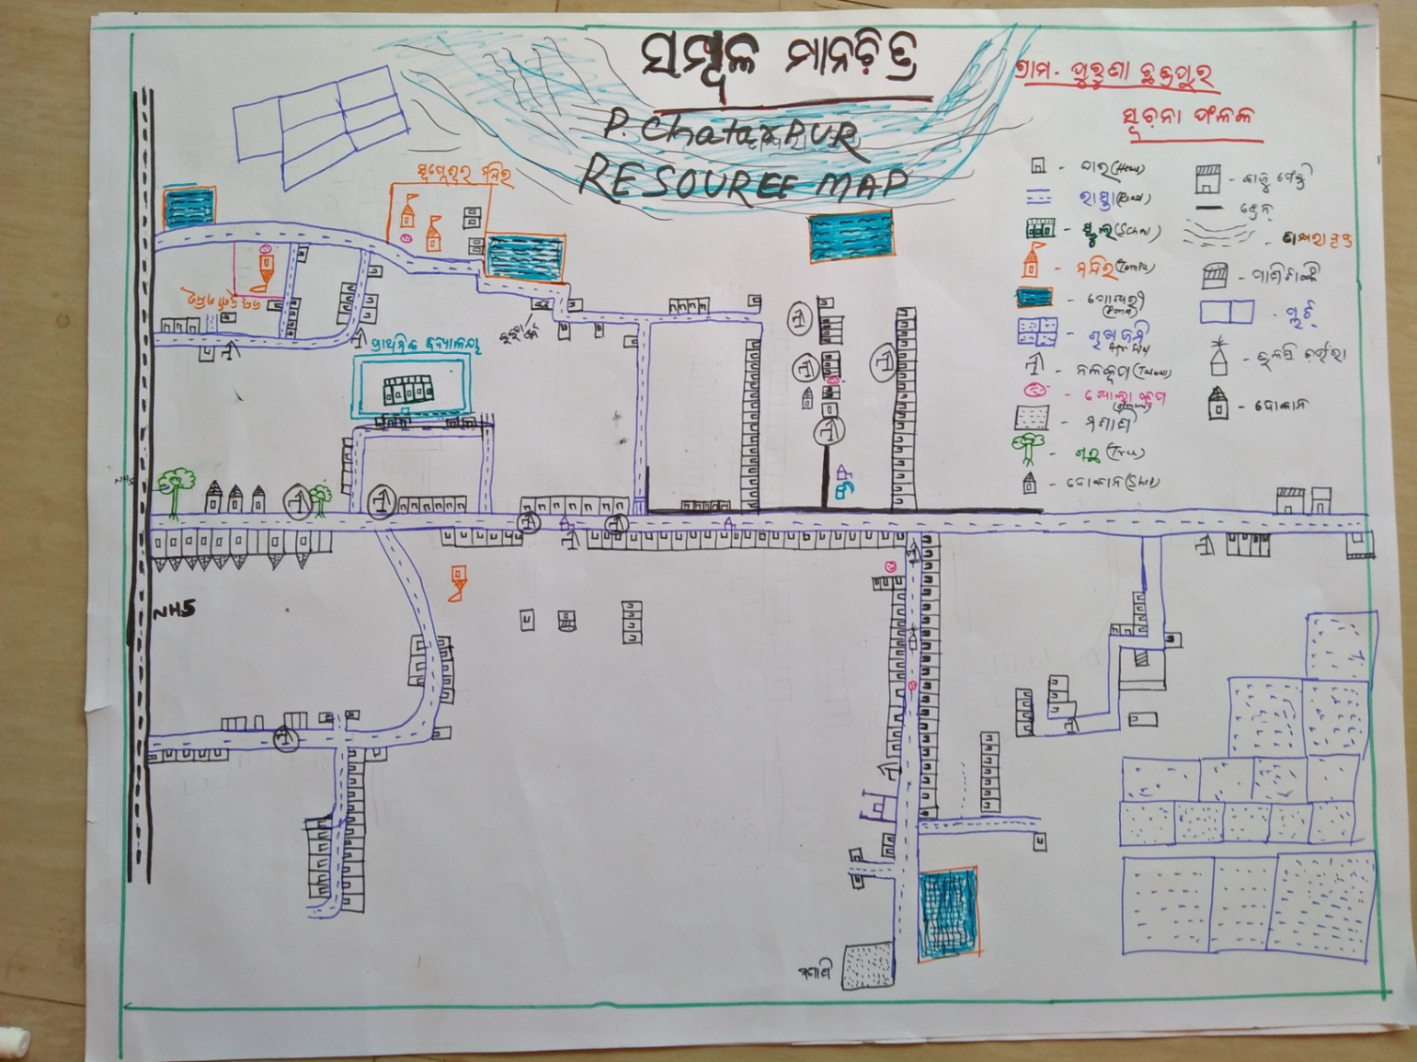
1) Resource Map

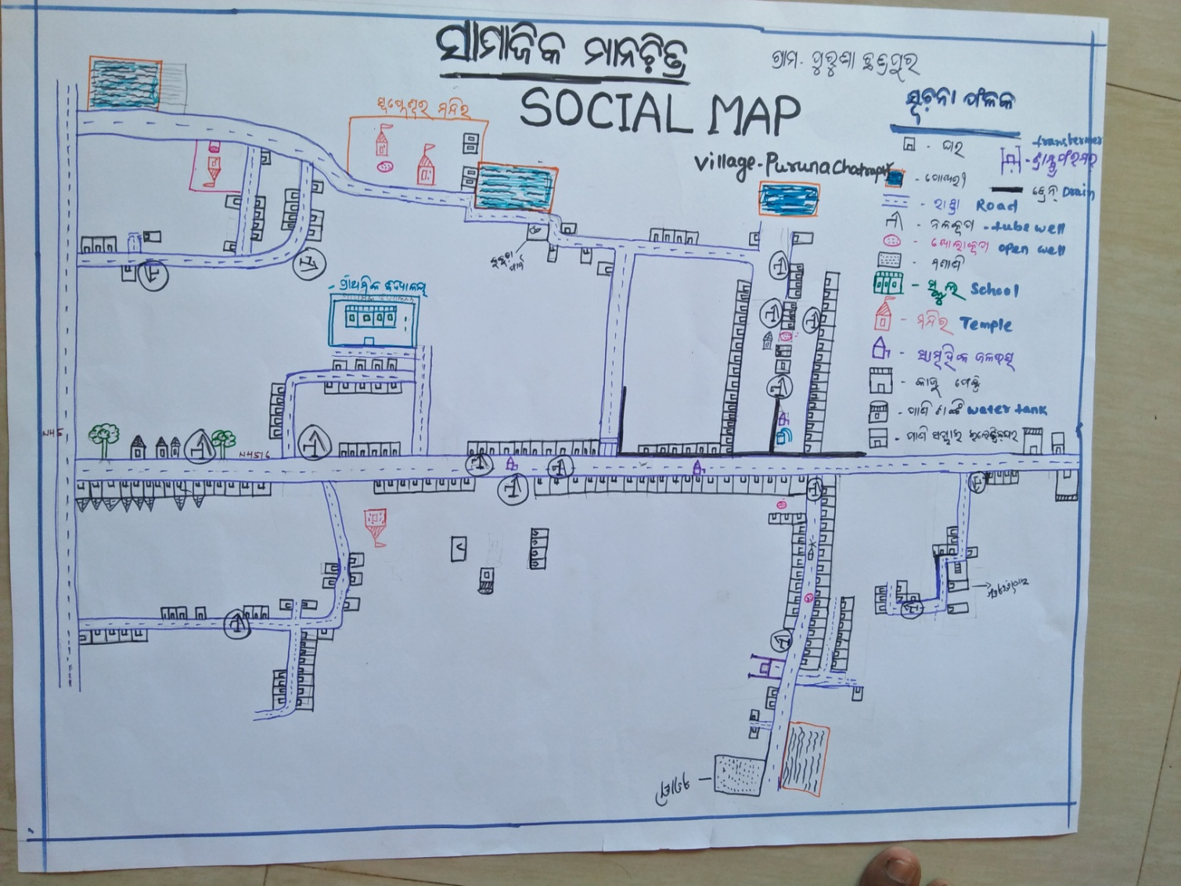
2) Social Map
23 . Water Bodies;-
SN | Surface water Bodies | Period for Which water Available | Purpose of Use | For Eache purpose indicate Month (From –to) | Who Manage
1 | River & Stream | 0 | 0 | 0 | 0
2 | Chanel & Canal | 0 | 0 | 0 | 0
3 | Lake | 0 | 0 | 0 | 0
4 | Pond | (JULY TO MAR)9 Month | Bathing washing irrigation | same | panchayat
5 | Open Dug well | 0 | 0 | 0 | 0

(Mark on Resource Map )
24. Seasonal Calendar For Resources Availability:-
 | Jan | Feb. | Mar | Apr | May | June | july | Aug | Sept | Oct | Nov | Dec
Capture Fishing | 0 | 0 | 0 | 0 | 0 | 0 | 0 | 0 | 0 | 0 | 0 | 0
Culture Fishing | 0 | 0 | 0 | 0 | 0 | 0 | 0 | 0 | 0 | 0 | 0 | 0
Aquatic plant collection | 0 | 0 | 0 | 0 | 0 | 0 | 0 | 0 | 0 | 0 | 0 | 0√
Agriculture | 0 | 0 | 0 | 0 | 0 | 0 | √ | √ | √ | √ | √ | √
Kaju collecting | 0 | 0 | √ | √ | √ | 0 | 0 | 0 | 0 | 0 | 0 | 0
Labour Wark Avilable | √√ | √√ | √√ | √√ | √√ | 0 | 0 | 0 | v | v | √√ | √√
Keoda collection | 0 | √ | √√ | v√ | v√ | v | 0 | √√ | √√ | √√ | 0 | 0

25. Hazard & Vulnerability Mapping :-
SN | Type of Hazard | Year of Hazard | Period of Hazard | If flood days when water Water logging | Areas Inundated
1 | Super cyclon | 1999 | october | 0 | 0
2 | phailin | 2014 | october | 0 | 0

26. Time &Trained Analysis of Resource Vulnerability:-
SN | Year | Type Hazard/Event | Effect/ affect Waterresourse
1 | 1982 | Jhada | Water loging
2 | 1999 | Super cyclone | Water loging 3days
3 | 2013 | phailin | Water loging 2days
4 | 2014 | Hood hood | No water loging

