WATERSHED INDIA- empowering citizens

Strategic Partnership – India Work Programme
Village Information Sheet
1. State: Odisha
2. District: Ganjam 3. Block: Chatrapur
4. Name of Gram Panchayat: Kanamana 5. Name of village: Matikhalo
6. Population of village: 2540 8. Total Household:- 668
7. Connectivity: Pucca/Kucha Road: Pucca Road
9. Distance from District headquarters: 07 km
10. Number of Hamlets : 06 1:- Gadamuha Sah i2:- Bada Sahi 3:- Padara Sahi 4:- Bandha Sahi
5:- Panda colony 6:- IRE Chaka 7:-Dadapradhan Sahi 8:- New Matikhalo 9:-Hadi Sahi 10:- Jaganath colony.
11. Social Group:- 1:- Sauntia 2:- Sundhi 3:-Liari 4:- Brahmana 5:-Dandasi 6;- Hadi 7:-Kachara 8:- Swain
12. Relizon:- Hindu
13. Social Group wise Catagory:-
General Category | S C Category | S T Category | OBC Category
Brahman | Dandasi | 0 | Sundhi
Swain | Sauntia | 0 | Lihari
0 | Hadi | 0 | Kachara
03 | 03 | 0 | 04

14. Sahi/Pada wise House hold(Social Group)
SN | Name of the Hamlet/Sahi | Household (general) | Household (SC) | Household (ST) | Household (OBC) | Total
1 | Gadamuha Sahi | 04 | 55 | 0 | 05 | 64
2 | Bada Sahi | 01 | 70 | 0 | 0 | 71
3 | Padara Sahi | 0 | 20 | 0 | 01 | 21
4 | Bandha Sahi | 0 | 77 | 0 | 02 | 79
5 | Panda colony | 08 | 41 | 0 | 05 | 54
6 | IRE Chhaka | 07 | 45 | 0 | 0 | 52
7 | Dandapradhan Sahi | 01 | 15 | 0 | 01 | 17
8 | New  Matikhalo | 02 | 53 | 0 | 02 | 57
9 | Hadi Sahi | 0 | 22 | 0 | 0 | 22
10 | Jaganath Colony` | 06 | 04 | 0 | 02 | 12

15.Sahi /pada wise Occupation
 | Gadamuha Sahi | Bada Sahi | Padara Sahi | Bandha Sahi | Panda colony | IRE Chhaka | Dandapradhan Sahi | New  Matikhalo | Hadi Sahi | Jaganath olony | Total
 | 1 | 2 | 3 | 4 | 5 | 6 | 7 | 8 | 9 | 10
Fishing | 0 | 0 | 0 | 0 | 0 | 0 | 0 | 0 | 0 | 0 | 0
Marginal Farmer (<2.5Acer) | 60 | 59 | 20 | 74 | 42 | 42 | 12 | 53 | 0 | 07 | 369
Medium/large Farmer>2.5 | 10 | 12 | 01 | 06 | 12 | 10 | 05 | 04 | 0 | 05 | 65
Labourers | 60 | 60 | 10 | 45 | 20 | 12 | 02 | 40 | 20 | 0 | 269
Service | 04 | 01 | 01 | 03 | 05 | 06 | 02 | 0 | 0 | 05 | 27
Small Business | 0 | 0 | 0 | 02 | 04 | 08 | 02 | 03 | 0 | 0 | 19
Keoda collection | 50 | 35 | 05 | 15 | 04 | 10 | 03 | 12 | 2 | 0 | 136
Keoda Processing | 0 | 0 | 0 | 0 | 0 | 0 | 0 | 0 | 0 | 0 | 0
Kaju collection | 15 | 20 | 05 | 40 | 02 | 29 | 05 | 45 | 0 | 0 | 161
Traditonal Ocu.Basket making | 0 | 0 | 0 | 0 | 0 | 0 | 0 | 0 | 9 | 0 | 09

16. Income Generation Unit in Village:-
1) Kaju Processing Unit -02 Kanamana
2) Keoda Processing Unit-02
17. Functional Village Water & sanitation Committee: - 02
18. Numbers of user / Pani Committee in the village:-No
(A) No separate Committee for water users
(B)Village GKS Committee Functioning.
19. Institution Mapping:-
SN | Institution | Type | Distance to Village | No of Centre | Key Authority/Point person | Role
1 | Anganwadi Centre | Centre, Sub Centre | In Village | 02 | AWW | Mother &Child Care
2 | School | Primery 1 to 5 | In Village | 01 | Head Master | Education
 |  | Upper primary | IRE Colony | 01 | Head Master | Education
3 | Health Centre | ANM | In Village | Camp | ANM/Asha | Health
4 | NGO | 0 | 0 | 0 | 0 | 0
5 | Bank | SBI, Indian Bank | 03 IRE Chaka | 02 Branch | Branch Manager | Savings Loan
6 | SHG |  | In village | 08 | Group Leader | Loan
7 | Post office | Village post office | Kanamana 02 KM | 01 | Post Master | Saving
8 | Panchayat Office |  | Kanamana 02 | 01 | Sarpanch | Village Dev Work
9 | Police station | Phandi | Chamakhadi 03 km | 01 | IIC | Protection
10 | Disaster Committee | Cyclone shelter | In village | 01 | Secretary | DRR
11 | Medical | District Medical | Chatrapur 04km
20. Main Source of Drinking Water:-
SN | Type Recourse | Nos/ units | Coverage (%Villagers) | Function
1 | Pipe water System Household connecting | O1 | 10%
2 | Hand Pump | 12 | 80%
3 | Open well | O1 | 02%
4 | Personal Burwell | 30 | 05%
5 | Personal open well | 04 | 05%
21. Sanitation Coverage:-
SN | Type | %of village population
1 | Toilet Coverage | 05%
2 | Toilet Usage | 05%
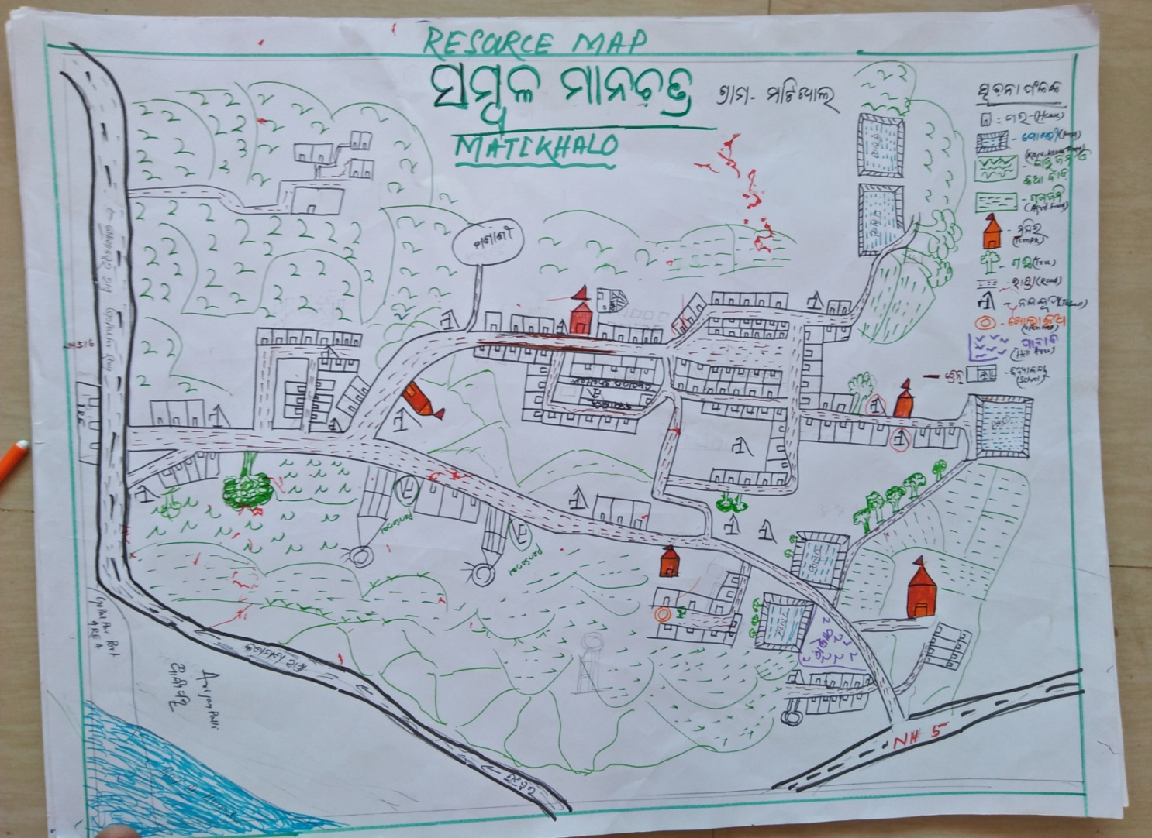
22. Recourse Map & Social Map
1) Resource Map
2) Social Map
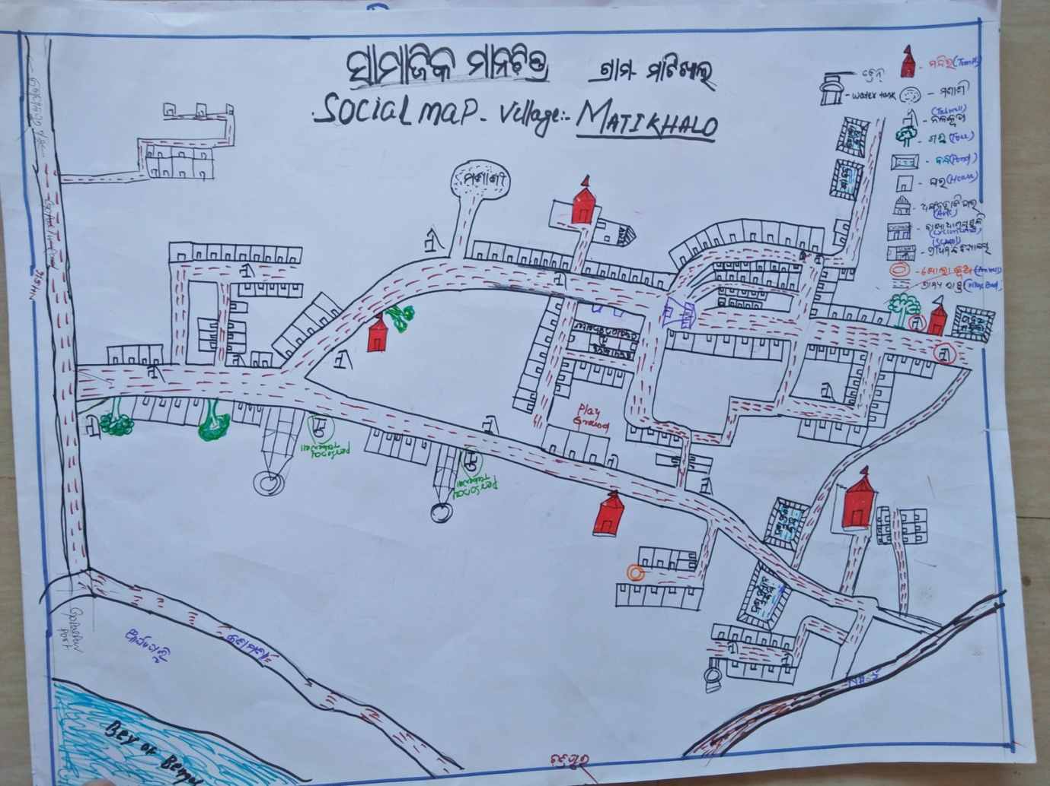
23.Water Bodies;-
SN | Surface water Bodies | Period for Which water Available | Purpose of Use | For Each purpose indicate Month (From –to) | Who Manage
1 | River & Stream | 0 | 0 | 0 | 0
2 | Chanel & Canal | 0 | 0 | 0 | 0
3 | Lake | 0 | 0
4 | Pond | 09 Month | Bathing Washing, Irrigation | April to June | Panchayat
5 | Open Dug well | 10 | Bathing, Drinking ,Washing | June to April
(Mark on Resource Map )
24. Seasonal Calendar For Resources Availability:-
 | Jan | Feb. | Mar | Apr | May | June | july | Aug | Sept | Oct | Nov | Dec
Capture Fishing | 0 | 0 | 0 | 0 | 0 | 0 | 0 | 0 | 0 | 0 | 0 | 0
Culture Fishing | 0 | 0 | 0 | 0 | 0 | 0 | 0 | 0 | 0 | 0 | 0 | 0
Aquatic plant collection | 0 | 0 | 0 | 0 | 0 | 0 | 0 | 0 | 0 | 0 | 0 | 0
Agriculture | 0 | 0 | 0 | 0 | √ | √ | √ | √ | √ | 0 | 0 | 0
Kaju collecting | 0 | 0 | √ | √ | √ | 0 | 0 | 0 | 0 | 0 | 0 | 0
Keoda collection | 0 | 0 | 0 | √ | √ | √ | √ | √√√ | √√√ | √ | √ | √
Keoda root collection | √ | √ | √ | √ | √ | √ | 0 | 0 | 0 | 0 | √ | √
Labour Work | √ | √ | √ | √ | √ | √ | √ | √ | √ | √ | √ | √

25. Hazard & Vulnerability Mapping :-
SN | Type of Hazard | Year of Hazard | Period of Hazard | If flood days when water logging | Areas Inundated
1 | Super cyclone | 1999 | October
 | 2013 | phailin | October
26. Time &Trained Analysis of Resource Vulnerability:-
SN | Year | Type Hazard/Event | Effect/ affect Waterresourse
 | 1999 | Super cyclone | Yes ,Wash System affected
 | 2013 | phailin | Wash System affected

