WATERSHED INDIA- empowering citizens

Strategic Partnership – India Work Programme
Village Information Sheet
1. State: Odisha
2. District: Ganjam 3. Block: Chatrapur
4. Name of gram panchayat: Kanamana 5. Name of village: KANAMANA
6. Population of village: 829 Total Household:- 168
7. Connectivity: Pucca/Kucha Road : Pucca
8. Distance from District headquarters:_07_km
9. Number of hamlets : 06 1:- Brundabati Nager 2:- Santi Colony 3:- Reddy Sahi 4:- Tulasi Nager
5:- Kanamana 6:- Shree hari Nager
10.Social Group:- 1:- Reddy,2:-Brahmin 3:-Dandasi 4:-Sundhi 5:- Dhoba 7:-Lihari 8: Doma 9:-Nolia
10:-sauntia
12. Houshold :-168
13. Social Group wise Catagory:-
General Category | S C Category | S T Category | OBC Category
Brahman | Dandasi | 0 | Sundhi
Baishanba | Dhoba | 0 | Lihari
0 | Doma | 0 | Nolia
0 | Sauntia | 0 | Reddy
02 | 04 | 0 | 04

14. Sahi/Pada wise House hold(Social Group)
SN | Name of the Hamlet/Sahi | Household (general) | Household (SC) | Household (ST) | Household (OBC) | Total
1 | Brundabati Nager | 0 | 20 | 0 | 0 | 20
2 | Shanti Colony | 05 | 05 | 0 | 06 | 16
3 | Reddy Sahi | 0 | 0 | 0 | 06 | 06
4 | Tulashi Nager | 05 | 03 | 0 | 04 | 12
5 | Kanamana | 13 | 36 | 0 | 60 | 109
6 | Shreehari Nager | 03 | 01 | 0 | 01 | 05
 | Total | 26 | 64 | 01 | 77 | 168

15.Sahi /pada wise Oqupation
 | Brundabati Nager(20) | Shanti  Colony(16) | Reddy Sahi(06) | Tulashi Nager(12) | Kanamana  (104) | Shreehari Nager(10) | Total  168
 | 1 | 2 | 3 | 4 | 5 | 6
Fishing | 0 | 0 | 0 | 0 | 0 | 0 | 0
Marginal Farmer (<2.5Acer) | 20 | 15 | 06 | 12 | 101 | 05 | 159
Medium/large Farmer>2.5 | 0 | 01 | 0 | 0 | 08 | 0 | 09
Labourers | 18 | 12 | 04 | 10 | 90 | 03 | 137
Service | 0 | 0 | 03 | 0 | 26 | 0 | 29
Small Business | 0 | 0 | 0 | 03 | 04 |  | 07
Keoda collection | 20 | 16 | 06 | 10 | 80 | 03 | 135
Keoda Processing
16. Income Generation Unit in Village:-
1) Kaju Processing Unit -02
2) Keoda Processing Unit-03
17. Functional Village Wate1r & sanitation Committee: - Yes
18. Numbers of user / pani committee in the village:-
No separate Committee for water users ,Village GKS Functioning & Same Member in both Committee.
19. Institution Mapping:-
SN | Institution | Type | Distance to Village | No of Centre | Key Authority/Point person | Role
1 | Anganwadi Center | Center | In Village | 01 | AWW | Mother &Child Care
2 | School | Primery | In Village | 01 | Head Master | Education
3 | Health Center | ANM | In Village | camp | ANM | Health
4 | NGO | Gram Vikas | In Village | 01 | Supervisor | WASH
5 | Bank | SBI, IndianBank | 02 IRE Chhaka | 02 Branch | Branch Manager | ,Loan
6 | SHG |  | In village | 04 | Group Leader | loan
7 | Post office | Village post office | Kanamana | 01 | Post Master | Saving
8 | Panchayat Office |  | In Village | 01 | Sarpanch | Village Dev Work
9 | Police station | PS | O7 | 01 | IIC | Protection
20. Main Source of Drinking Water:-
SN | Type Recourse | Nos/ units | Coverage (%Villagers) | Function
1 | Pipe water System Household connecting | O2 | 95 % | ok
2 | Hand Pump | 03 | 70% | ok
3 | Open well | O1 | 95 % | ok
4 | Personal Burwell | 05 | 05% | ok
5

21. Sanitation Coverage:-
SN | Type | %of village population
1 | Toilet Coverage | 98%
2 | Toilet Usege | 98%
22. Resource Map & Social Map
1) Resource Map
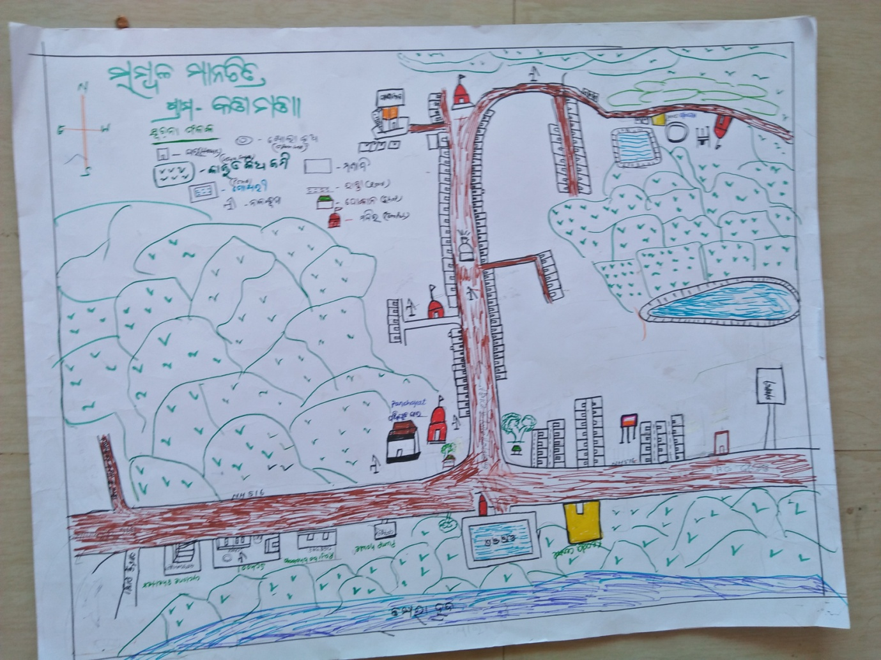
2) Social Map
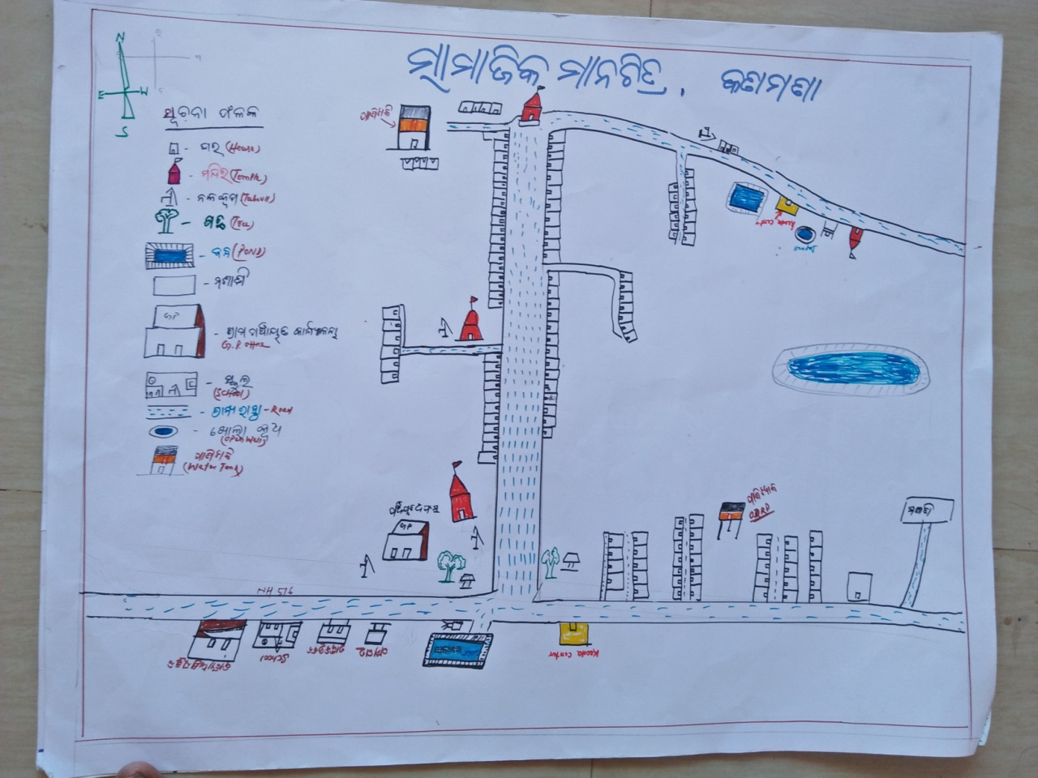

23.Water Bodies;-
SN | Surface water Bodies | Period for Which water Available | Purpose of Use | For Eache purpose indicate Month (From –to) | Who Manage
1 | River & Stream | 0 | 0 | 0 | 0
2 | Chanel & Canal | 0 | 0 | 0 | 0
3 | Lake | 0 | 0 | 0 | 0
4 | Pond | 05 (July to Feb) | Wasing,Irrgation,fishing | Same | Pachayat
5 | Open Dug well | 01 (Jan To Dec) | Drinking water | Same | Pani Comitte
(Mark on Resource Map )
24. Seasonal Calendar For Resources Availability:-
 | Jan | Feb. | Mar | Apr | May | June | july | Aug | Sept | Oct | Nov | Dec
Capture Fishing | 0 | 0 | 0 | 0 | 0 | 0 | 0 | 0 | 0 | 0 | 0 | 0
Culture Fishing | 0 | 0 | 0 | 0 | 0 | 0 | 0 | 0 | 0 | 0 | 0 | 0
Aquatic plant collection | 0 | 0 | 0 | 0 | 0 | 0 | 0 | 0 | 0 | 0 | 0 | 0
Agriculture | 0 | 0 | 0 |  | 0 | √ | √ | √ | √
Kaju collecting | 0 | 0 | √ | √ | √ | 0 | 0 | 0 | 0 | 0 | 0 | 0
Keoda collection | 0 | 0 | 0 | √ | √ | √ | √√√ | √√√ | √√√ | √ | √ | √

25. Hazard & Vulnerability Mapping :-
SN | Type of Hazard | Year of Hazard | Period of Hazard | If flood days when water Water logging | Areas Inundated
1 | Super cyclon | 1999 | October
2 | phailin | 2013 | October
26. Time &Trained Analysis of Resource Vulnerability:-
SN | Year | Type Hazard/Event | Effect/ affect Waterresourse
 | 1999 | Supecycole
 | 2010 | Pipe water conection
 | 2013 | phailin

