WATERSHED INDIA- empowering citizens

Strategic Partnership – India Work Programme
Village Information Sheet
1. State: Odisha
2. District: Ganjam 3. Block:- Chatrapur
4. Name of gram panchayat:-Arijaypalli. 5. Name of village:- K Arijapali
6. Population of village:- 2605 7. Total Household:-670
8. Connectivity: Pucca/Kucha Road :- Pucca
9. Distance from District headquarters:-08.km
10. Number of hamlets ( Pada /Sahi) :- 09
11 . Name of Pada/Sahi 1:- K Arijayapali 2:- Gitamandira Sahi 3:-Amabhagaban Sahi 4:-Narashingh Mandira Sahi 5;-Bhajagobinda Sahi,6:-GurubabuSahi 7:-Indira Abasha Sahi 8:-Narayan mandira sahi 9:-Hanumana Sahi
11.Social Group:- 1:-Nolia 2:-Kandra 3:-Gudia 4:-Sundhi 5:-Brahmna 6:- Sahoo 7:-sauntia
12.Religion 1: Hindu 2:-Christan
13. Social Group wise Catagory:-
General Category | S C Category | S T Category | OBC Category
Brahamini | Kandra | 0 | Nolia
0 | Sauntia | 0 | Sahoo
0 | 0 | 0 | Sundhi
0 | 0 | 0 | Gudia

14. Sahi/Pada wise House hold(Social Group)
SN | Name of the Hamlet/Sahi | Household (general) | Household (SC) | Household (ST) | Household (OBC) | Total
1 | K arjayapali | 02 | 215 | 0 | 03 | 220
1 | Gita Mandira Sahi | 01 | 0 | 0 | 49 | 50
2 | Amabhagaban Sahi | 0 | 0 | 0 | 38 | 38
3 | Narashingh Mandira Sahi | 0 | 12 | 0 | 84 | 96
4 | Bhajagobinda Sah | 03 | 02 | 0 | 80 | 85
5 | Gurubababu Sahi | 0 | 0 | 0 | 60 | 60
6 | Indira Abasha Sahi | 0 | 0 | 0 | 34 | 34
7 | Narayan mandira sahi | 0 | 0 | 0 | 45 | 45
8 | Hanumana Sahi | 0 | 0 | 0 | 45 | 45
total |  | 06 | 229 | 0 | 538 | 670

15.Sahi /pada wise Oqupation
 | K Arijaypali | Gita Mandira Sahi | Amabhagaban sahi | Narashingh Mandira Sahi | Bhajagobinda Sahi | Gurubabu Sahi | Indira Abas Sahi | Narayan Mandira sahi | Hanuman mandir sahi
 | 1 | 2 | 3 | 4 | 5 | 6 | 7 | 8 | 9
Fishing | 0 | 49 | 38 | 121 | 95 | 80 | 35 | 60 | 60
Marginal Farmer (<2.5Acer) | 4 | 01 | 0 | 0 | 0 | 0 | 0 | 0 | 0
Medium/large Farmer>2.5 | 0 | 0 | 0 | 0 | 0 | 0 | 0 | 0 | 0
Labourers | 215 | 49 | 38 | 121 | 95 | 80 | 35 | 60 | 60
Service | 20 | 0 | 0 | 02 | 01 | 0 | 0 | 0 | 0
Small Business | 20 | 01 | 0 | 05 | 05 | 04 | 0 | 01 | 06
Keoda collection | 0 | 01 | 0 | 0 | 0 | 0 | 0 | 0 | 0
Kaju collection | 6 | 0 | 0 | 0 | 0 | 0 | 0 | 0 | 0

106. Income Generation Unit in Village/Near village
1) Kaju Processing Unit :- in near village Kanamana.
2) Keoda Processing Unit:- in near village Kanamana.
3) Incomegeneration Activites/Unit.:- Gopalpur Port ,Fishing Jethi, IRE &Briks Industri End of the Village Labour work available.
17. Functional Village Water & sanitation Committee: - No
18. Numbers of user / pani committee in the village:-N0
No separate Committee for water users ,Village GKS Functioning but one for a Revinue village.
19. Institution Mapping:-
SN | Institution | Type | Distance to Village | No of Centre | Key Authority/Point person | Role
1 | Anganwadi Center | Centre,subcentre | In village | 04 | AWW | Child and mother care
2 | School | primary | K arjyapalli | 1 | Head master | education
3 | Health Center | camp | In village | camp | ANM | Health
4 | NGO | 0 | 0 |  | 0 | 0
5 | Bank | SBI Gopalpur port | 01km | 01 | Bank mananger | Loan & Savings
6 | SHG | women | In village | 04 | CRP | loan
7 | Post office | Sub post office | In Bada aryapalli | 01 | Post man | comuniction
8 | Panchayat Office | panchayat | Bada aryapalli | 01 | sarapanch | Village dev work
9 | Police Station | Police station | Bada arjyapalli | 01 | iic | protection

20. Main Source of Drinking Water:-
SN | Type Recourse | Nos/ units | Coverage (%Villagers) | Function
1 | Pipe water System Household connecting | 0 | 0 | Only ODRE Schem one for GP
2 | Hand Pump | 04 | 30 | function
3 | Open well | 04 | 0
4 | Personal Burwell | 422 | 90% | function
5 | Personal open well | 20 | 5%
6 | Stad Post | 01

21. Sanitation Coverage:-
SN | Type | %of village population
1 | Toilet Coverage | 15%
2 | Toilet Usage | 75%

22. Resource Map & Social Map
1) Resource Map of Katuru Village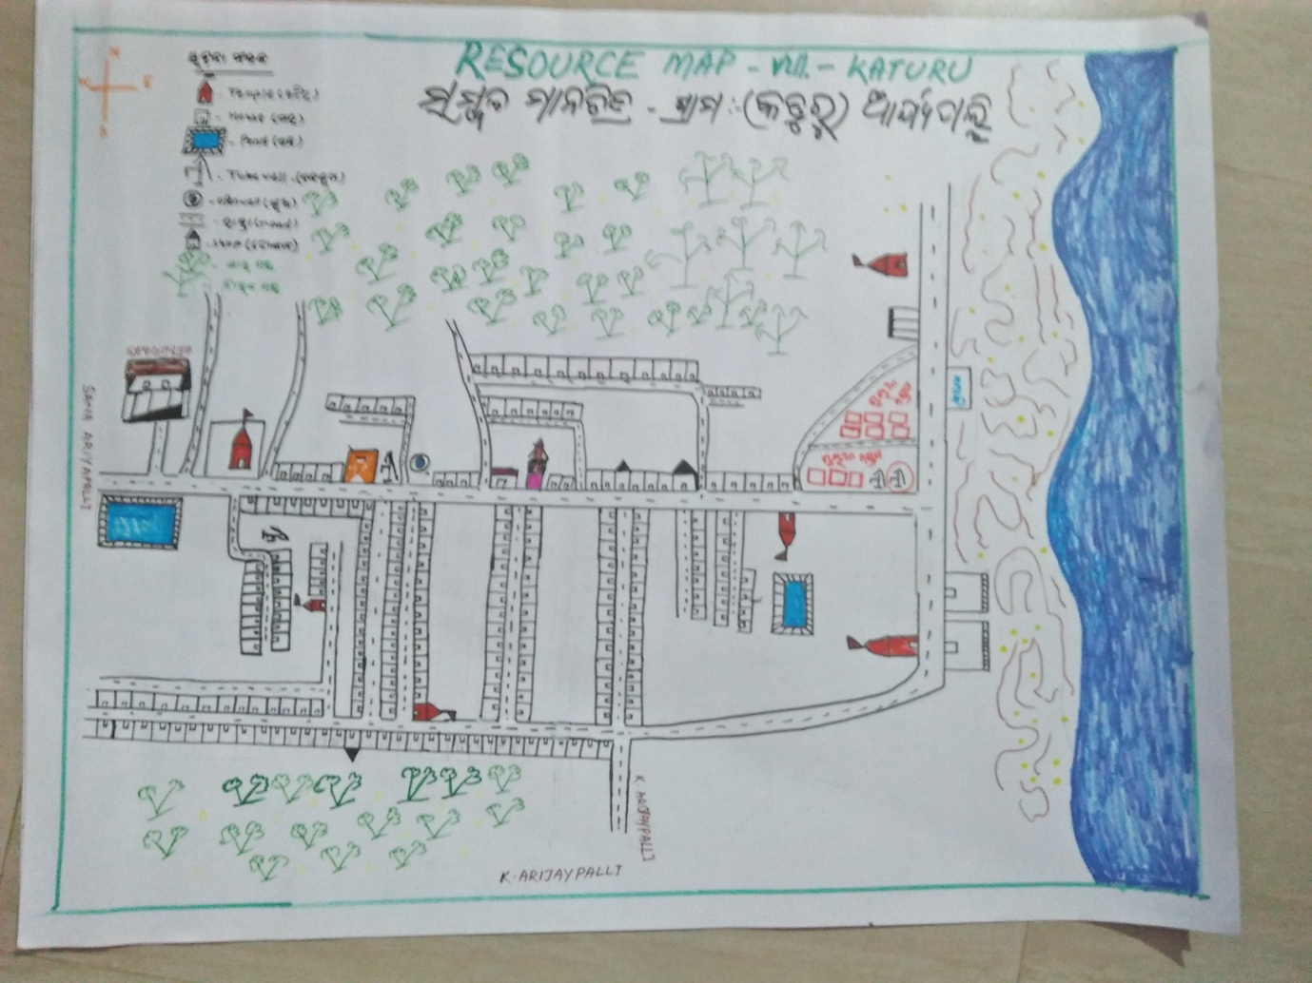

2) Social Map of Katuru Village
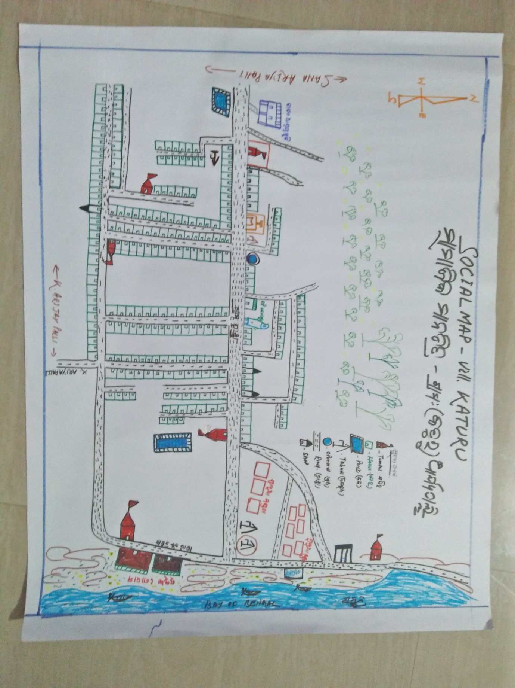

- Resource Map of K Arjyapalli
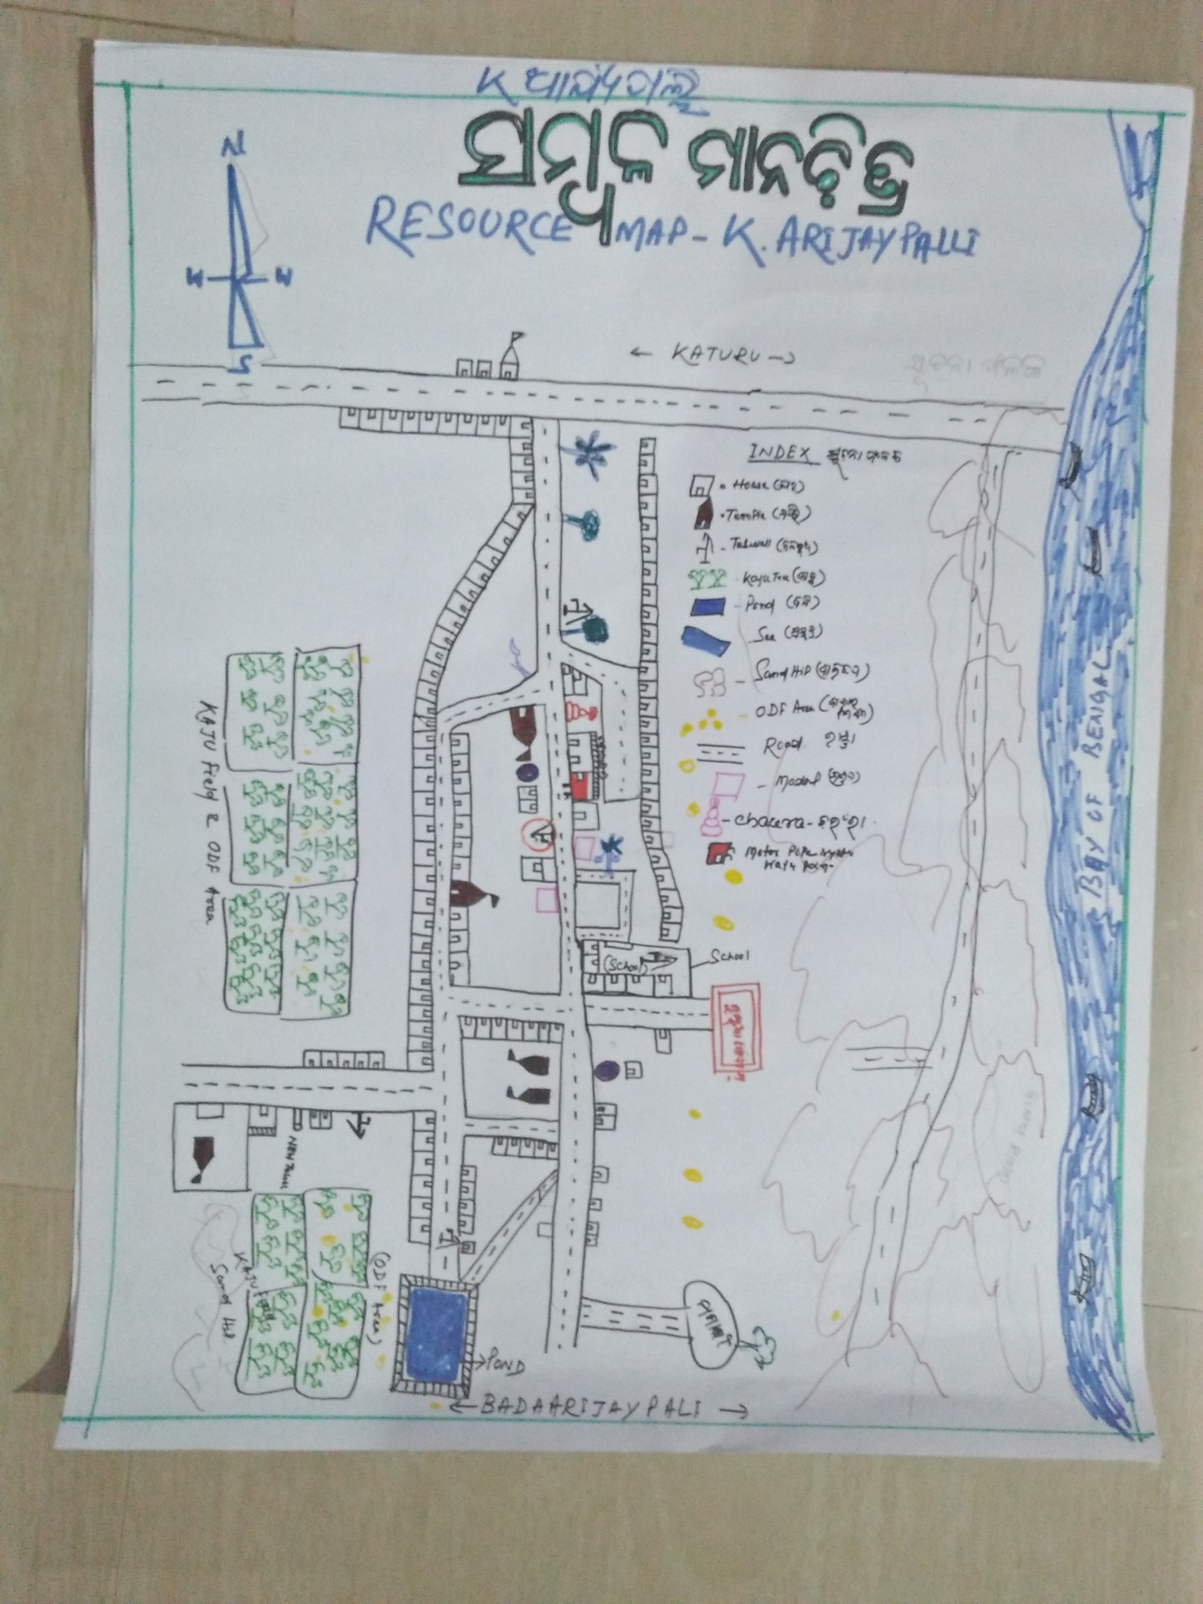

- Social Map
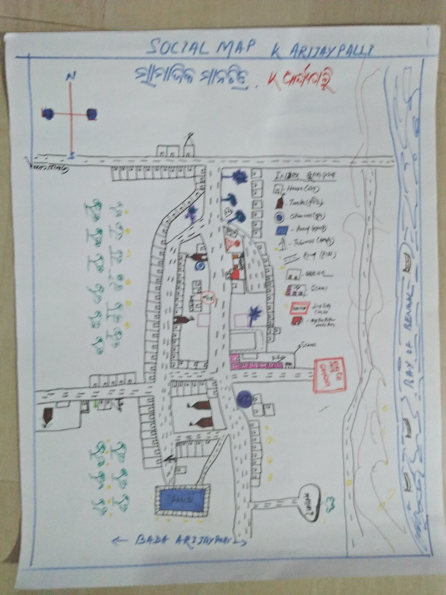

23 . Water Bodies;-
SN | Surface water Bodies | Period for Which water Available | Purpose of Use | For Eache purpose indicate Month (From –to) | Who Manage
1 | River & Stream | 0 | 0 | 0 | 0
2 | Chanel & Canal | 0 | 0 | 0 | 0
3 | Lake | 0 | 0 | 0 | 0
4 | Pond | 12months | Washing ,bathing | Jan-dec | panchayat
5 | Open Dug well | 0 | 0 | 0 | 0
(Mark on Resource Map )
24. Seasonal Calendar For Resources Availability:-
 | Jan | Feb. | Mar | Apr | May | June | july | Aug | Sept | Oct | Nov | Dec
Capture Fishing | √ | √ | √ | √ | √ | √ | √ | √ | √ |  | √ | √
Culture Fishing | 0 | 0 | 0 | 0 | 0 | 0 | 0 | 0 | 0 | 0 | 0 | 0
Aquatic plant collection | 0 | 0 | 0 | 0 | 0 | 0 | 0 | 0 | 0 | 0 | 0 | 0
Agriculture | 0 | 0 | 0 | 0 | 0 | 0 | 0 | 0 | 0 | 0 | 0 | 0
Kaju collecting | 0 | 0 | 0 | 0 | 0 | 0 | 0 | 0 | 0 | 0 | 0 | 0
Keoda collection | 0 | 0 | 0 | 0 | 0 | 0 | 0 | 0 | 0 | 0 | 0 | 0

25. Hazard & Vulnerability Mapping :-
SN | Type of Hazard | Year of Hazard | Period of Hazard | If flood days when water Water logging | Areas Inundated
1 | Super cyclon | 1999
2 | phailin | 2013

26. Time &Trained Analysis of Resource Vulnerability:-
SN | Year | Type Hazard/Event | Effect/ affect Waterresourse
1 | 1999 | Super Cycone | Pond & Tubewell fill with Salain water
2 | 2013 | Phaini | Pond & Tubewell fill with Salain water
3 | 2014 | Hoodhud

