WATERSHED INDIA- empowering citizens

Strategic Partnership – India Work Programme
Village Information Sheet
1. State: Odisha
2. District: Ganjam 3. Block: Chatrapur
4. Name of gram panchayat: -Arjayapalli 5. Name of village: -Bada Arjaypalli
6. Population of village: 3185 7. Total Household:-647
8. Connectivity: Pucca/Kucha Road : Pucca
9. Distance from District headquarters: 10 km
10. Number of Hamlets ( Pada /Sahi) : 13
11 . Name of Pada/Sahi 1:- Indira Abasasahi 2:-Gola Sahi 3:-Baragachha Sahi 4:-old postoffice Sahi 5:- New Post office Sahi 6:-Thakurani Sahi 7:-DealerSahi 8:- Khandia sahi 9:- Main Road Sahi 10:-Tanda Sahi 11:-PortChaka Sahi 12:- Betala Sahi 13:- Nrimalapanda Sahi
11.Social Group:- 1:- Nolia.2:-Dhoba 3:-Nayak 4:-Bhandari 5: -Sundhi 6:-Brmhana 7:-Moharana 8:-Kandra 9:-lihari 10:-Khandayat 11:-Gola 12:-Jena
12.Religion Hindu & khristan
13. Social Group wise Catagory:-
General Category | S C Category | S T Category | OBC Category
Brmhana | Dhoba | Jena | Nolia
0 | Nayak | 0 | Sundhi
0 | Kandara | 0 | Bhadari
0 | 0 | 0 | Moharana
0 | 0 | 0 | Khandyat
0 | 0 | 0 | lihari
0 | 0 | 0 | Gola

14. Sahi/Pada wise House hold(Social Group)
SN | Name of the Hamlet/Sahi | Household (General) | Household (SC) | Household (ST) | Household (OBC) | Total
1 | Indrbas sahi | 0 | 02 | 0 | 59 | 61
2 | Gola sahi | 0 | 0 | 0 | 52 | 52
3 | Baragachha sahi | 0 | 01 | 0 | 55 | 56
4 | Old post office sahi | 0 | 0 | 01 | 26 | 27
5 | New post office sahi | 0 | 0 | 0 | 24 | 24
6 | Thakurani sahi | 0 | 0 | 0 | 56 | 56
7 | Dilar sahi | 0 | 0 | 0 | 71 | 71
8 | Khandia sahi | 0 | 0 | 0 | 24 | 24
9 | Main road sahi | 01 | 0 | 0 | 71 | 72
10 | Tanda sahi | 0 | 0 | 0 | 60 | 60
11 | Port chhak sahi | 0 | 04 | 0 | 01 | 05
12 | Betal sahi | 0 | 02 | 0 | 63 | 65
13 | Nirmal panda sahi | 0 | 0 | 0 | 75 | 75

15.Sahi /pada wise Oqupation
 | Indrbas sahi | Gola Sahi | Baragacha Sahi | Old Postoffice sahi | New Post office sahi | Thakurani Sahi | Dilar Sahi
 | 1 | 2 | 3 | 4 | 5 | 6 | 7
Fishing | 57 | 48 | 50 | 25 | 24 | 55 | 70
Marginal Farmer (<2.5Acer) | 0 | 0 | 0 | 0 | 0 | 0 | 0
Medium/large Farmer>2.5 | 0 | 01 | 0 | 0 | 0 | 0 | 0
Labourers | 57 | 45 | 50 | 25 | 24 | 50 | 64
Service | 0 | 02 | 01 | 0 | 0 | 0 | 03
Small Business | 0 | 0 | 5 | 4 | 0 | 06 | 05
Keoda collection | 0 | 0 | 0 | 0 | 0 | 0 | 0
Keoda Processing | 0 | 0 | 0 | 0 | 0 | 0 | 0

15.Sahi /pada wise Oqupation (Continue)
 | Khandia Sahi | Mainroad Sahi | Tanda Sahi | Port Sahi | Betala Sahi | Nirmalapanda Sahi
 | 8 | 9 | 10 | 11 | 12 | 13
Fishing | 23 | 65 | 53 | 0 | 64 | 72
Marginal Farmer (<2.5Acer) | 0 | 0 | 0 |  | 0 | 0
Medium/large Farmer>2.5 | 0 | 0 | 0 |  | 0 | 0
Labourers | 20 | 50 | 43 | 05 | 64 | 72
Service | 01 | 04 | 01 | 01 | 01 | 02
Small Business | 02 | 12 | 15 | 02 | 0 | 0
Keoda collection | 0 | 0 | 0 | 0 | 0 | 0
Keoda Processing | 0 | 0 | 0 | 0 | 0 | 0
16. Income Generation Unit in Village:-
1) Kaju Processing Unit :-Kaju processing centre in kanamana
2) Keoda Processing Unit:-No
3; Incomegeneration Activites/Unit:-Gopal pur port Fishing Jethi
17. Functional Village Water & sanitation Committee: - No
18. Numbers of user / pani committee in the village:-No
No separate Committee for water users ,Village GKS Functioning & Same Member in both Committee.
19. Institution Mapping:-
SN | Institution | Type | Distance to Village | No of Centre | Key Authority/Point person | Role
1 | Anganwadi Center | Centre | In village | 04 | Aww | Child & Mother Care
2 | School | Primary &High | In village | 02 | Head Master | education
3 | Health Center | Camp | In village | Camp | ANM | Health Care
4 | NGO | No | No | No | No | No
5 | Bank | SBI of Gopalpur | In village | 01 | Bank mananger | Money Trasction
6 | SHG | Women | In village | 34 | CRP | Saving and Loan
7 | Post office | Sub post Office | In village | 01 | Post man | Communication
8 | Panchayat Office | Panchayat Office | In Village | 01 | Sarapancha | Village Dev
9 | Police Station | Police Station | Near sea shore | 01 | IIC | Guard
20. Main Source of Drinking Water:-
SN | Type Recourse | Nos/ units | Coverage (%Villagers) | Function
1 | Pipe water System Household connecting | 0 | 0 | 0
2 | Hand Pump | 11 | 70% | Function
3 | Open well | 0 | 0 | 0
4 | Personal Burwell | 80 | 30% | Function
5 | Personal open well | 0 | 0 | 0

21. Sanitation Coverage:-
SN | Type | %of village population
1 | Toilet Coverage | 20%
2 | Toilet Usage | 80%

22. Resource Map & Social Map
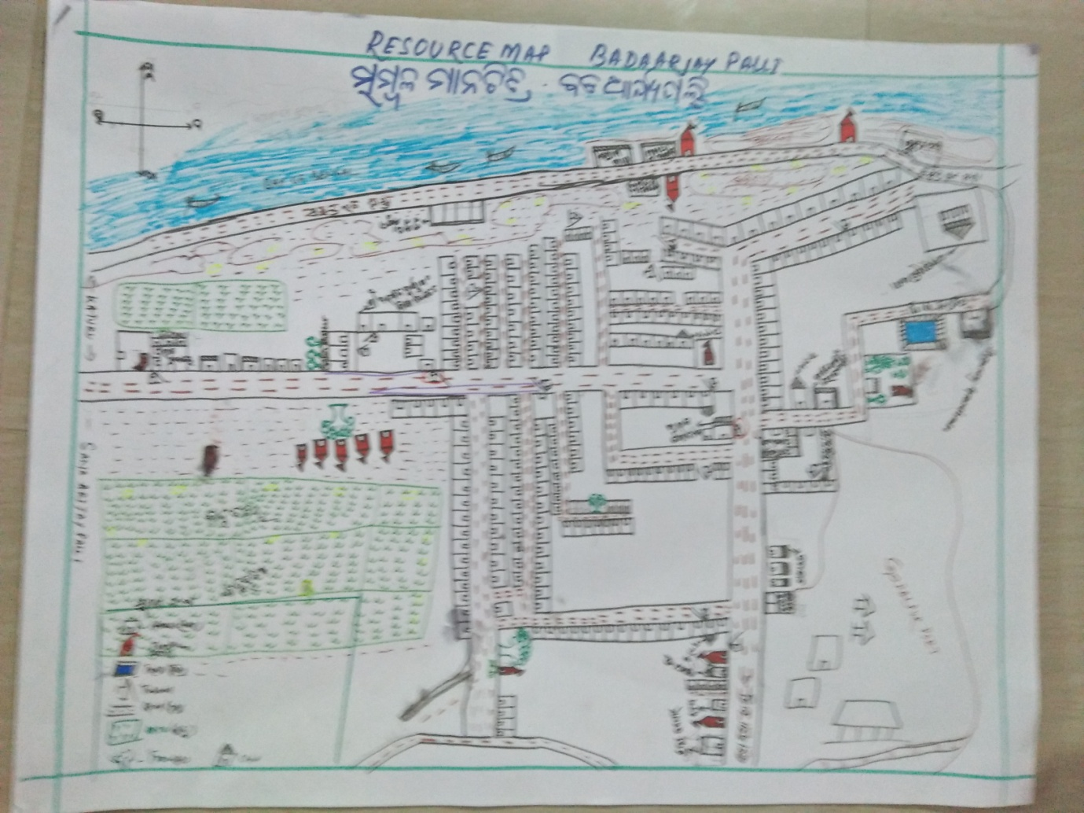
1) Resource Map
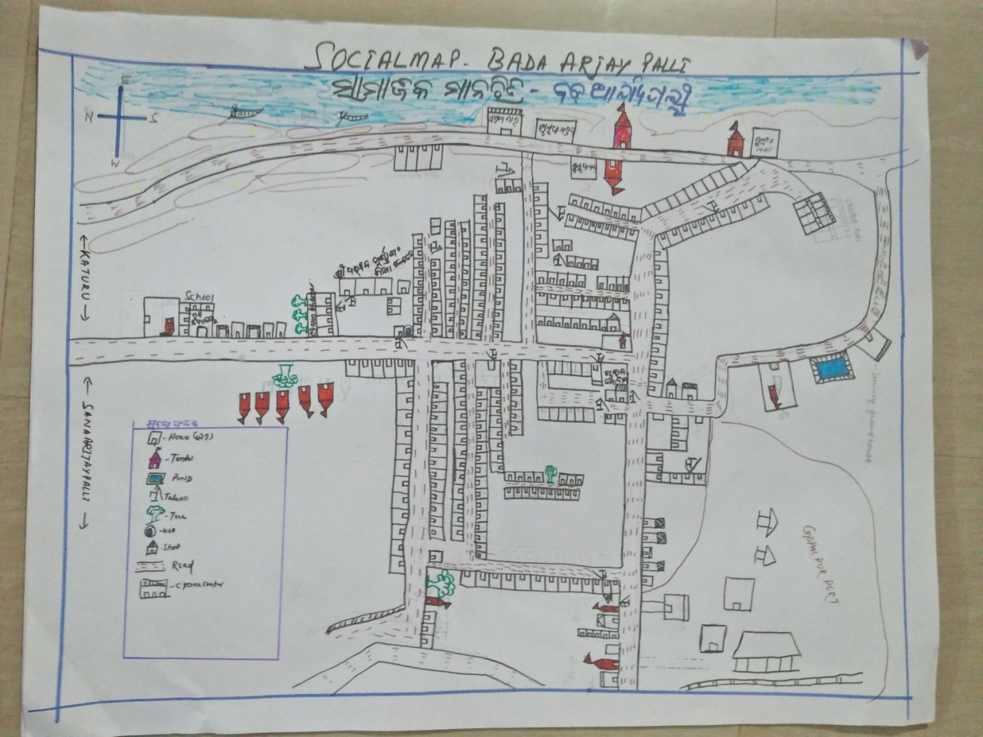
2) Social Map
23 . Water Bodies;-
SN | Surface water Bodies | Period for Which water Available | Purpose of Use | For Eache purpose indicate Month (From –to) | Who Manage
1 | River & Stream | NA | NA | NA | NA
2 | Chanel & Canal | NA | NA | NA | NA
3 | Lake | NA | NA | NA | NA
4 | Pond | 12Months | Washing,Bathing | Jan-Dec | Panchayat
5 | Open Dug well | NA | NA | NA | NA
(Mark on Resource Map )
24. Seasonal Calendar For Resources Availability:-
 | Jan | Feb. | Mar | Apr | May | June | july | Aug | Sept | Oct | Nov | Dec
Capture Fishing | √ | √ | √ | √ | √ | √ | √ | √ | √ | √ | √ | √
Culture Fishing | 0 | 0 | 0 | 0 | 0 | 0 | 0 | 0 | 0 | 0 | 0 | 0
Aquatic plant collection | 0 | 0 | 0 | 0 | 0 | 0 | 0 | 0 | 0 | 0 | 0 | 0
Agriculture | 0 | 0 | 0 | 0 | 0 | 0 | 0 | 0 | 0 | 0 | 0 | 0
Kaju collecting | 0 | 0 | 0 | 0 | 0 | 0 | 0 | 0 | 0 | 0 | 0 | 0
Keoda collection | 0 | 0 | 0 | 0 | 0 | 0 | 0 | 0 | 0 | 0 | 0 | 0

25. Hazard & Vulnerability Mapping :-
SN | Type of Hazard | Year of Hazard | Period of Hazard | If flood days when water Water logging | Areas Inundated
1 | Super cyclon | 1999 | Oct
2 | phailin | 2013 | Oct

26. Time &Trained Analysis of Resource Vulnerability:-
SN | Year | Type Hazard/Event | Effect/ affect Waterresourse
1 | 1999 | Super Cycone | Pond & Tubewell fill with Salain water, down area
2 | 2013 | Phailin | Pond & Tubewell fill with Salain water ,Down area
3 | 2014 | Hoodhud | No

