WATERSHED INDIA- empowering citizens

Strategic Partnership – India Work Programme
Village Information Sheet
1. State: Odisha
2. District: Ganjam 3. Block: Chatrapur
4. Name of Gram Panchayat: -AgastiNuagaon 5. Name of village:- AgastiNuagaon
6. Population of village: 1593 7. Total Household:-324
8. Connectivity: Pucca/Kucha Road : Pucca
9. Distance from District headquarters:-09 km
10. Number of hamlets ( Pada /Sahi) : - 07
11 . Name of Pada/Sahi 1:- Uper Sahi 2:- Khandia sahi 3:-School Sahi 4:-Nuasahi 5:-Majhi Sahi
06:-Sundhi Sahi 07:-BauriSahi
11.Social Group:- 1:-
12.Religion .............................
13. Social Group wise Catagory:-
General Category | S C Category | S T Category | OBC Category

14. Sahi/Pada wise House hold(Social Group)
SN | Name of the Hamlet/Sahi | Household (general) | Household (SC) | Household (ST) | Household (OBC) | Total
1
2
3
4
5
6

15.Sahi /pada wise Oqupation
 | 1 | 2 | 3 | 4 | 5 | 6 | 7 | 8 | 9 | 10
Fishing |  |  |  |  |  |  |  |  |  | 0
Marginal Farmer (<2.5Acer)
Medium/large Farmer>2.5
Labourers
Service
Small Business
Keoda collection
Keoda Processing
16. Income Generation Unit in Village:-
1) Kaju Processing Unit .....................
2) Keoda Processing Unit..............................
3; Incomegeneration Activites/Unit...................................
17. Functional Village Water & sanitation Committee: - .............
18. Numbers of user / pani committee in the village:-
No separate Committee for water users ,Village GKS Functioning & Same Member in both Committee.
19. Institution Mapping:-
SN | Institution | Type | Distance to Village | No of Centre | Key Authority/Point person | Role
1 | Anganwadi Center
2 | School
3 | Health Center
4 | NGO
5 | Bank
6 | SHG
7 | Post office
8 | Panchayat Office
9 | Police Station
20. Main Source of Drinking Water:-
SN | Type Recourse | Nos/ units | Coverage (%Villagers) | Function
1 | Pipe water System Household connecting
2 | Hand Pump
3 | Open well
4 | Personal Burwell
5 | Personal open well

21. Sanitation Coverage:-
SN | Type | %of village population
1 | Toilet Coverage
2 | Toilet Usage

22. Resource Map & Social map
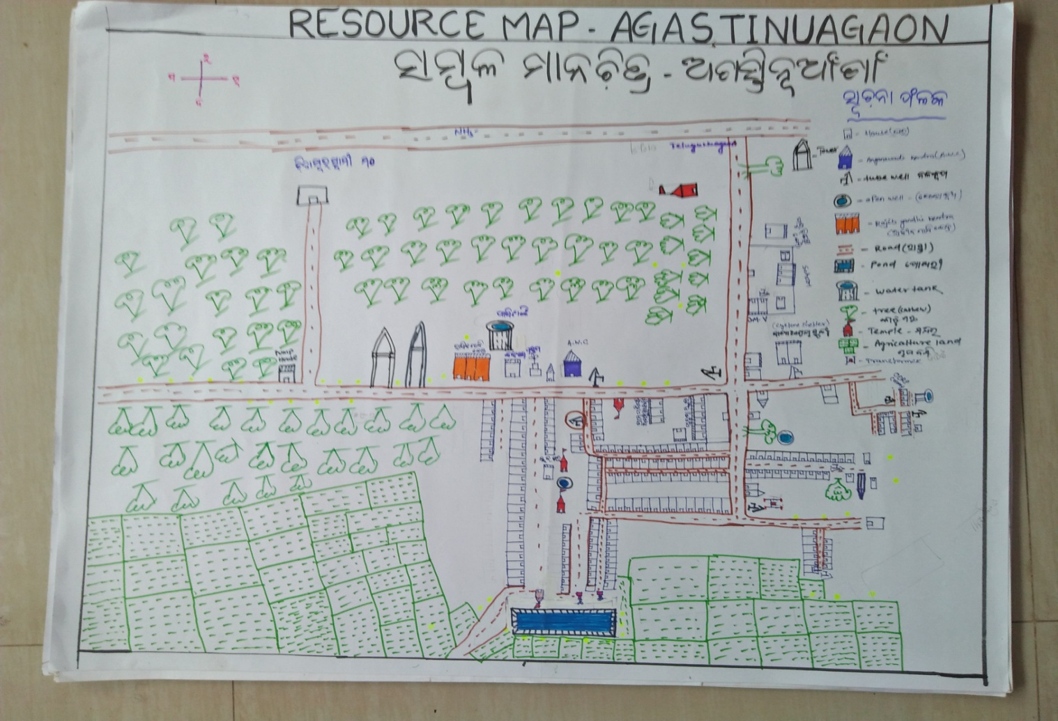
1) Resource Map
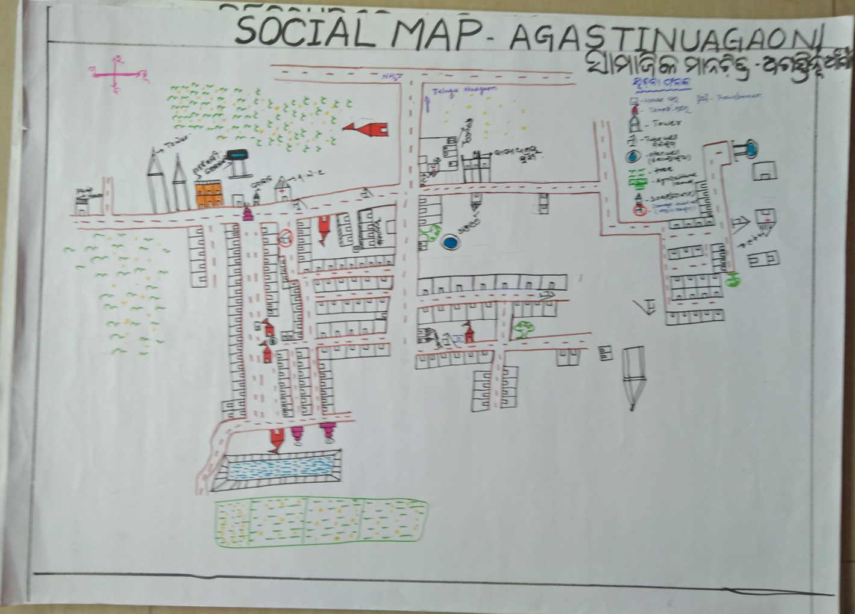
2) Social Map
23 . Water Bodies;-
SN | Surface water Bodies | Period for Which water Available | Purpose of Use | For Eache purpose indicate Month (From –to) | Who Manage
1 | River & Stream
2 | Chanel & Canal
3 | Lake
4 | Pond
5 | Open Dug well
(Mark on Resource Map )
24. Seasonal Calendar For Resources Availability:-
 | Jan | Feb. | Mar | Apr | May | June | july | Aug | Sept | Oct | Nov | Dec
Capture Fishing
Culture Fishing
Aquatic plant collection
Agriculture
Kaju collecting
Keoda collection

25. Hazard & Vulnerability Mapping :-
SN | Type of Hazard | Year of Hazard | Period of Hazard | If flood days when water Water logging | Areas Inundated
1 | Super cyclon | 1999
2 | phailin | 2013
26. Time &Trained Analysis of Resource Vulnerability:-
SN | Year | Type Hazard/Event | Effect/ affect Waterresourse
1 | 1999 | Super Cycone | Pond & Tubewell fill with Salain water
2 | 2013 | Phaini | Pond & Tubewell fill with Salain water
3 | 2014 | Hoodhud

